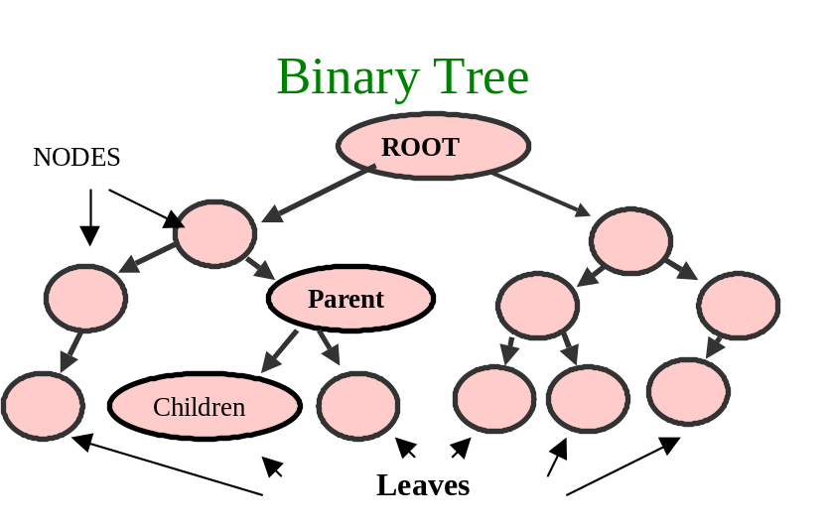

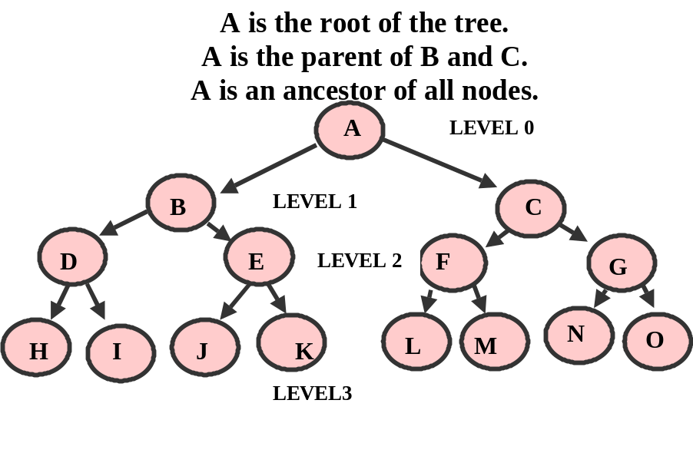

Binary Search Tree:
A binary search tree with no duplicates :
- Every node in the left subtree is less than its parent node.
- Every node in the right subtree is greater than its parent node
- When the tree is traversed in order, the values of the nodes will be in order.

If less than
go left
else
go right

The Following BST is built by entering the following numbers:

50 25 75 12 33 67 88 6 13 68

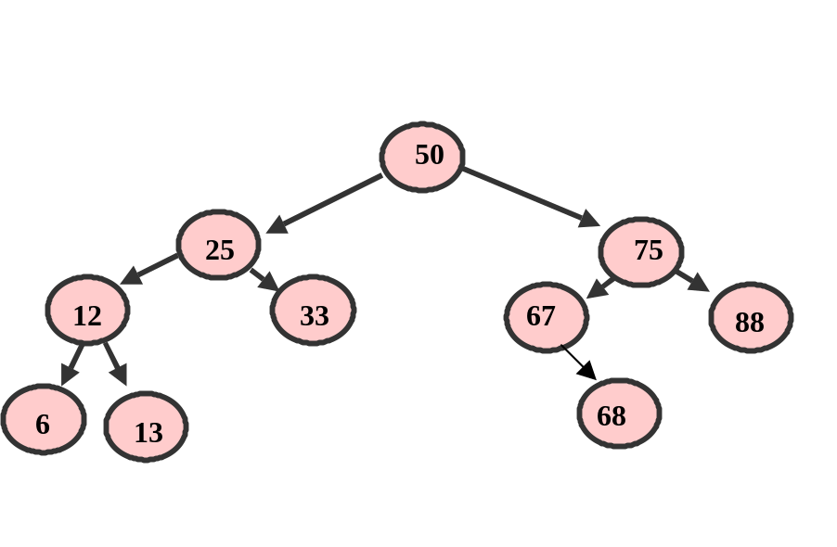PREORDER TRAVERSAL (node ---- left subtree ---- right subtree):

50 25 12 6 13 33 75 67 68 88

WHY ? recursive process starts at ROOT then goes left, that node (#25) is itself a parent (root of) node #12. Node #12 is itself a parent (root of) node #6

Node #6 is a leave so right subtree can be processed, 1st #13 (right child of node 12)
Then #33 (right child of node 25) Then #75 (right node of 50)

Then #75 is a parent (root of) 2 children. We go left to #67.
#67 is itself a parent (root of) for 1 child #68. Since #67 has no left child, #68 is processed.

Node #68 is a leave so right subtree of #75 can be processed. #75 has only a right child, so it is processed (#88)

POSTORDER TRAVERSAL (left subtree ---- right subtree ---- node):

6 13 12 33 25 68 67 88 75 50

recursive process starts at lowest left subtree of the lowest parent (#6), then that parents right subtree (#13) is processed. Then the parent #12 is processed.

Then the next parent (#25) has its right subtree processed #33

Then the parent #25 is processed.

Then the children of the lowest right parent (#67) are processed. Since #67 has no left child,
Its right child, #68, is processed. Then the parent #67 is processed.

Then the next parent (#75) has its right subtree processed #88

Then the parent #75 is processed.

Then the root #50 is processed

INORDER TRAVERSAL (left subtree ---- node ---- right subtree):

6 12 13 25 33 50 67 68 75 88

recursive process starts at lowest left subtree of the lowest parent (#6),
Then the parent #12 is processed.
Then that parents right subtree (#13) is processed.

Then the next parent #25 is processed
Then #25’s right child is processed (#33)

Then the next parent #50 is processed
Then #50’s lowest right parent’s node is processed #67 (#67 has no left node)
Then #67’s right child #68 is processed

Then #75 is processed
Then #75’s right child is processed #88

